***Spring Semester (March 27, 2019)***



***World Food Production***

***Bowie State University/Feed the Hungry***

***Kayla Wright***

***CTEC 128***

***Introduction***

As the world’s population continues to grow, achieving global food security, which is to produce enough nutritious food that everyone can access, and doing so sustainably. Geometrically, great pressure is being placed on arable land, water, energy, and biological resources to provide an adequate supply of food while maintaining the integrity of our ecosystem. This is one of the greatest challenges we face today. According to the United Nations Food and Agriculture Organization (FAO), by 2050, our world population is expected to grow from 7.3 billion today to 9.7 billion and recent estimates suggest that food production will have to increase by 70% if we are to feed everyone. The proportion of undernourished people has increased from 16 million in 1990-92 to 33 million today. Currently 134 million children are born every year, that is 367 thousand per day, and there are approximately 56 million deaths per year. At this rate, the population is predicted to reach 8 billion by 2027 and about 9 billion by 2046. We find ourselves in a position today where the world is currently not able to feed all of its inhabitants. Currently, more than one billion people are estimated to lack sufficient food, and more than twice that number do not receive adequate nutrition. This situation will likely become a lot more dire in the future.Almost one-third of children under the age of five face lifelong health and development impairment due to insufficient access to nutritious foods. At the same time, the region has rising rates of overweight and obesity, creating an unforeseen amount of malnutrition. This presents an enormous challenge and necessitates the need to find sustainable ways to grow food to feed this expanding population. Just like the challenge is enormous, the solutions and approaches we employ to tackle this challenge and achieve food security must be broad. There are many diverse sources of food, and populations around the world have very different diets and demands. We must use a wide range of tools and technologies and draw from several approaches including climate smart agriculture practices and the use of biotech crops. At the same time, these tools must be sensitive to our environments. So the question remains: How do we feed our growing population?

***Mission/Concepts***

Feed the Hungry (FH), a non-profit organization/data science team that is dedicated to fighting hunger and poverty across the globe. FH is concerned about the availability of food for the world’s most vulnerable population. The organization’s leaders want to create strategic plan for the future to ensure that there is enough food to feed everyone. The areas we would like to focus on are, the United States, India, China, and Brazil. These areas are the top food producing areas based off the data set provided. 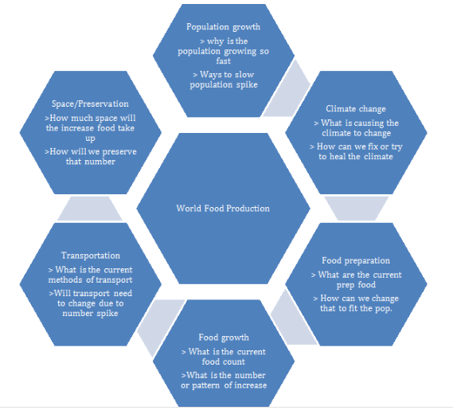

The research questions that the organization we put together are; Why is there going to be such a population boost in 31 years? What do the world’s highest food countries produce and how? How much space do we need to farm and distribute the food? Why is it that some of the largest countries produce very little food? What kinds of food being produced are the easiest to grow? These questions help guide the research for how data should be gathered, and how to begin the research. Just like the challenge is enormous, the solutions and approaches we employ to tackle this challenge and achieve food security must be broad.

A multi-targeted approach will be required to help overcome the many challenges. This will include looking at how new approaches to food production and changes to the supply chain can boost efficiency. The Concept Map helped create ideas and build relationships to other ideas from the information presented. In the first slot, population growth is an important aspect to pay attention to when working with food production because a person needs to know how much food needs to be produced for a growing population. Climate change is an important factor when working with food production because agriculture has always been at the mercy of unpredictable weather, but a rapidly changing climate is making agriculture an even more harder to maintain. This could either reduce food supply or make food prices higher because there may be no way for them to produce the crops fast enough. According to the state of the planet article by Renee Cho, about eighty percent of the world’s crops are rainfed, so most farmers depend on the predictable weather agriculture has adapted to in order to produce their crops. Food preparation includes the way that our foods are being processed. Businesses use food processing techniques to transform raw foods and ingredients into new products. This could help present ways to create more food. Food processing offers important benefits to businesses and consumers, including a more varied food supply and foods with a longer shelf life. Processing can also help to inhibit or destroy pathogens (disease-causing organisms) that may contaminate food. Processing can also create products that require little or no preparation on the part of consumers. Food growth is an important factor as well because we need to understand the patterns of increase of the food count. Transportation is an important factor in food production because food storage methods during transportation have a great impact on its safety and quality. This is because transportation conditions favor the different deterioration and infestation processes. Therefore, in order to maintain proper quality, food handlers need to limit access to the products by harmful microorganisms and prevent population growth and colonization. The time and temperature control is important during transportation because any food left under a certain temperature for too long, is favorable breeding ground for pathogens. The last point in the concept map is space and preservation which also could be linked to transporting the food. Dry food products are a lot easier to handle during the preservation process than their perishable counterparts.

**Getting the Data**

Data, in today’s business and technology world, is indispensable. The Big Data technologies and initiatives are rising to analyze this data for gaining insights that can help in making strategic decisions. The concept evolved at the beginning of 21st century, and every technology giant is now making use of Big Data technologies. Big Data refers to vast and voluminous data sets that may be structured or unstructured. This massive amount of data is produced every day by businesses and users. Big Data analytics is the process of examining the large data sets to underline insights and patterns. The Data analytics field in itself is vast. Big data can be analyzed for insights which lead organizations to take better decisions and also help them in making strategic moves, and also help narrow down your results. Un-wrangled data is messy and there are too many results with it as well. In the unwrangled data set given for world food production, there were a total number of 64 variables and a total number of 12,748 observations. Data wrangling is the process of cleaning, structuring and enriching raw data into a desired format for better decision making in less time. The wrangled data set includes categories for each of the variable and variable types. The wrangled data included headers like variable name, level of measurement and others. Mathematical equations were included like mean, minimum and maximum.

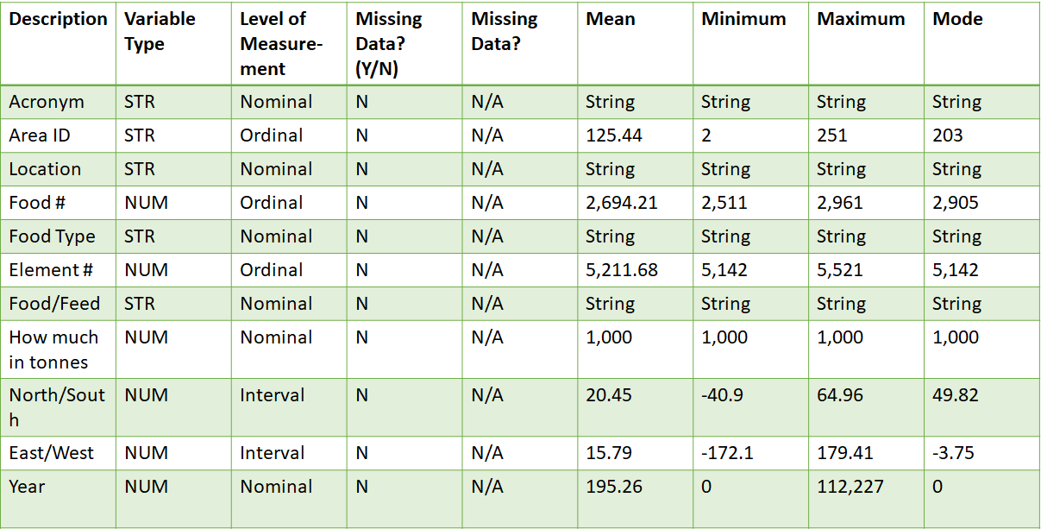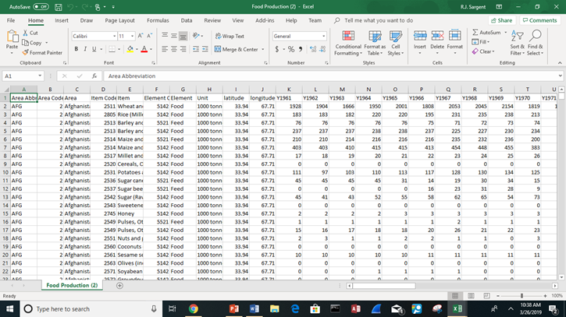

In the data set given, the organization found that the top food producing regions were Brazil, India, China, and the United States of America. Based off of the United States Census Bureau, of the four, the top three were China, India, and the United States of America. The data estimates from the U.S. Census Bureau put China in the lead with 1.34 billion residents, followed by India with 1.19 billion. The United States is a distant third with 311.1 million people from 2011. Rounding out the top five are Indonesia at 245.6 million and Brazil at 203.4 million.

The bureau envisions India taking the worldwide lead by 2050, when its estimated population will be 1.66 billion. The comparable 2050 projections for China and the United States are 1.30 billion and 422.6 million, respectively.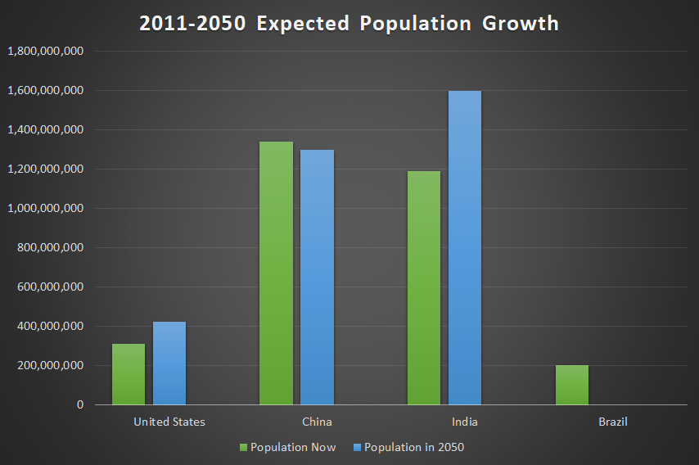

**Data Insights**

Since the top food producing regions are the China, India, the United States of America, and Brazil, the organization believed it was best to find reasons why these regions were at the top. China is number one with an amount of 1,557,870,339 in food production. Brazil is next with an amount of 1,087,212,419 in food production. Next is India with an amount of 1,029,308,228 in food production. Lastly is the United States of America with an amount of 792,658,677 in food production. 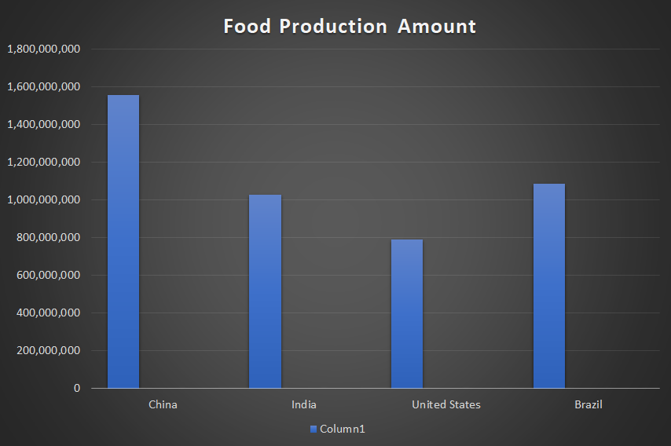

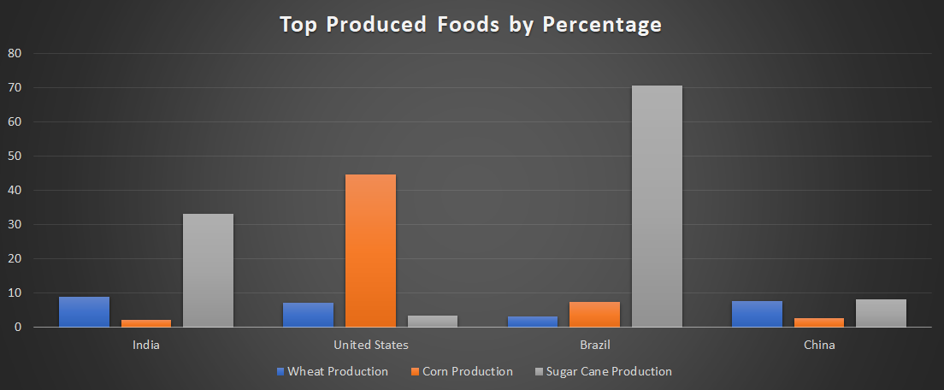

An important factor to know if what food each region produces the most of. Agriculture accounts for 18% of the economy’s output and 47% of its workforce. Corn is the most produced food in the United States followed by soybeans & milk. Chicken is the most produced animal protein in the United States followed by beef and pork. Beef is the 10th most produced food in the United States. Corn is the most produced food commodity in China followed by rice and fresh vegetables. They produce more than 100 million tons of 5 food commodities: corn, rice, vegetables, sugar cane and wheat. Pork is the most produced animal protein followed by chicken and beef. India is the second biggest producer of fruits and vegetables in the world. Sugar cane is the most produced food commodity in India followed by rice and wheat. India produces more buffalo milk than cow milk. India produces 70 million tons of buffalo milk and more than 60 million tons of cow milk.India produces more bananas than corn or soybeans. Yet according to the Food and Agriculture Organization (FAO) of the United Nations, some 194 million Indians are undernourished, the largest number of hungry people in any single country. Sugar cane is the most produced food commodity in Brazil followed by soybeans and corn. Chicken is the most produced animal protein followed by beef and pork. Beef is the 9th most produced food in Brazil. Sugar cane accounts for 71% of Brazil's food commodity production. Based off of the data provided, corn, sugar cane, and wheat is one of the top 5 produced foods of all four regions.

The top food produced in Brazil is sugar cane. Its vast landscapes and diverse climates offering opportunities to grow huge varieties of produce, Brazil is one of the most significant players in global food production. The country is one of the world's largest agricultural producers and exporters, with soybeans, corn, coffee, sugar and cotton accounting for some of its most significant crops. With wheat being another top produced food, it's important to take in consideration how this food could help assist with food production. Wheat is the third-largest field crop produced in the United States following corn and soybeans. U.S. wheat production is classified into five major classes: hard red winter, hard red spring, soft red winter, white and durum. Each class has different end-uses, and production tends to be region-specific which is listed in the table below. Hard red winter and hard red spring wheat account for 60% percent of production. These classes are primarily used to produce bread flour. Soft red winter represents 23% of wheat production and is used in the production of cakes, crackers, and cookies. White wheat accounts for 15% of production and is used in noodles, crackers and cereal products. White wheat is a relatively broad category that includes both soft and hard varieties, as well as spring and winter varieties. Durum wheat is used to produce pasta.

|  |  |  |  |
| --- | --- | --- | --- |
| **Class** | **2018 Production,**  **in Bushels** | **Location Produced** | **Uses** |
| Hard Red Winter | 661 million | Great Plains (TX to MT) | Bread flour |
| Hard Red Spring | 583 million | Northern Plains (ND, MT, MN, SD) | High-protein blending |
| Soft Red Winter | 292 million | Eastern States | Cakes, cookies, crackers |
| White | 267 million | WA, OR, ID, MI, NY | Flour for noodles, crackers, cereals |
| Durum | 73 million | ND, MT | Pasta |

Since corn is one of the top produced foods in the top food producing areas, it's important to find reasons why other regions should grow this crop to help world food production. Corn can be found in: starch, oil, food sweeteners, alcohol, as well as livestock feed and biofuel that assists global food security. Corn has adapted to just about every climate that humans have adapted to. Tropical and temperate, dry and rainy, cool and warm.” Which means there’s a huge gene pool to choose from when changing conditions make further adaptation necessary. Scientists estimate corn production will need to increase by 12 percent per acre between 2016 and 2035 in order to maintain current production levels. In order to increase crop yields, additional technology advancements will be necessary. Besides corn being a food, it also helps with the way we live our everyday lives and with production. According to Farm Progress, plastics aren’t entirely made up of synthetic substances, corn-based plastics have become very popular in recent years as companies strive to find methods for reducing the [environmental impact](http://commodityhq.com/2012/why-alternative-energy-will-never-become-widespread-in-our-lifetime/) of plastics. Corn based plastics use up to 68% less fossil fuels in production than traditional plastics, and are estimated to emit 55% less greenhouse gases. Oddly, some batteries also contain corn derivatives found in the form of “bioelectricity.” In batteries, cornstarch is often used as an electrical conductor, and if needed this could help with other ways to help produce foods. Lastly, the vast majority of commercially distributed vitamin C is derived from corn. Corn is rich with vitamin C, and half a cup of corn contains roughly 33% of your suggested daily intake of vitamin C.

**Results and Insights**

From the data analysis, the organization ‘Feed the Hungry’ learned that the United States of America, China, Brazil and India’s population is growing at rapid rates, and there will be drastic changes within the next few years. Food production would have to increase at a faster rate than the growth of the nation to keep up. From using the data sets, it helps a person analyze large sets of data, as well as uncover hidden patterns and correlations. Strategies for the future must be based first and foremost on the conservation and careful management of land, water, energy, and biological resources needed for food production.

**Discussion**

The purpose of the report is to provide solutions to find ways to assist with the growing world population in order to make sure there is an adequate amount of food for everyone. The job for Feed the Hungry (FH), was to fighting hunger and poverty across the globe. FH is concerned about the availability of food for the world’s most vulnerable population. The organization’s leaders wanted to create strategic plan for the future to ensure that there is enough food to feed everyone. For final recommendations, to alleviate this crisis we can begin to grow better crops, simply eat less meat, and target food for direct consumption. (Crops are not always used for food for humans, they are also used for things like oil, clothes,plastic and cosmetics.) Based off of the data set provided, it would be a great idea to know how much food people from each region actually intake. That would help with the final results of finding a solution to assist with food production. In the end, if we adopt the ways of top food producing regions, there is a great change that we could solve this major issue.

References

D. (2012). IMPACT OF POPULATION GROWTH ON FOOD SUPPLIES AND ENVIRONMENT by David Pimentel, Xuewen Huang, Ana Cordova, and Marcia Pimentel. Retrieved from

<http://www.dieoff.com/page57.htm>

Fowler, J. (2018, December 10). 13 ways corn is used in our everyday lives. Retrieved from

<https://www.farmprogress.com/vegetables/13-ways-corn-used-our-everyday-lives>

Stordalen, G. A. (2015). 4 ways to improve food productivity. Retrieved from

https://www.weforum.org/agenda/2015/05/4-ways-to-improve-food-productivity/

Top 25 Most Produced Foods In The United States. (2014). Retrieved from

<https://beef2live.com/story-top-25-produced-foods-united-states-147-120679>

Wheat. (2011). Retrieved from

<https://www.agmrc.org/commodities-products/grains-oilseeds/wheat>

Why Sustainable Food Production Is So Important. (2016, June 21). Retrieved from

<http://www.farmingsolutions.org/sustainable-food-production-important/>

|  |  |
| --- | --- |
|  |  |
|  | |  | | --- | |  | |